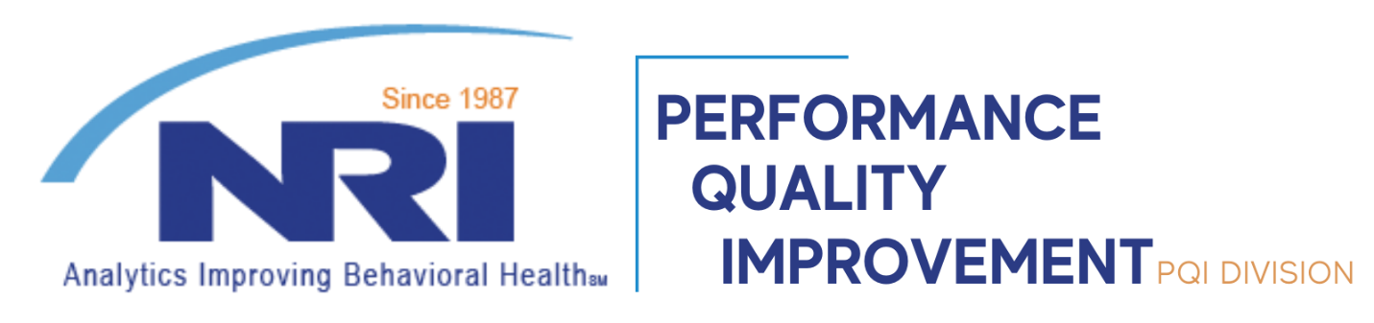

As part of our ongoing commitment to assist facilities in improving tobacco cessation activities we are posting this update from the Smoking Cessation Leadership Center regarding recent recalls of varenicline (Chantix, and others) following the discovery of lots containing over 39 ng of nitrosamines. We encourage review of this and other forthcoming FDA and scientific documents tracking this concern to inform decision making for prescribing to clients for tobacco cessation support.

Detailed tobacco cessation improvement resources are available at no cost with NRI: <https://www.nri-inc.org/focus-areas/performance-measurement/clinical-oversight/tobacco-cessation/>

9/16/2021

Dear Colleagues,

Please find attached an informal update regarding the status of varenicline and nitrosamines.  Doug Jorenby, PhD, Director of Clinical Services at UW-CTRI, kindly took the lead on preparing this document.  A few observations from co-author Dr. Mike Fiore:

* This should be viewed as an interim update and not the definitive summary of this complex issue.
* In many ways,we *don’t*know more than we know at this point.
* By the end of the calendar year, hopefully, the dust will have settled and we will have more definitive information.
* Again, we are hopeful that by that point or soon thereafter, we will have a reliable source of varenicline with known levels of this novel nitrosamine and helpful guidance from the FDA regarding using it.

Thank you,

Smoking Cessation Leadership Center

The Smoking Cessation Leadership Center developed and sponsors the 100Pioneers listserv. Messages posted on the listserv represent only the views of the individuals posting the messages. The SCLC does not endorse the accuracy of any posted statements. Moreover, information obtained through this list does not necessarily represent the views, positions or policy of the SCLC.

**2021 Varenicline Update Regarding Nitrosamine Contaminants**

**Douglas Jorenby, PhD and Michael Fiore, MD, MPH, MBA**

**University of Wisconsin Center for Tobacco Research and Intervention**

**September 15, 2021**

**What we know:**

* As a result of ongoing FDA concerns dating back to at least 2019 regarding nitrosamine impurities in medications (metformin, ranitidine, etc.), the FDA in September 2020 established an acceptable intake limit (AI) of varenicline nitrosamine inpurities at 37 nanograms/18.5 ppm. This limit was based upon an estimated increased risk of cancer of in one individual among 100,000 taking a drug containing that nitrosamine every day for 70 years at that AI or greater.
* Pfizer identified N-nitroso-varenicline (a novel nitrosamine) in samples of varenicline produced by them in the summer of 2021 (see also 24 Feb 2021 FDA *Guidance to Industry*). Some tested lots of varenicline contained 150-470 ng per tablet (155-474 ppm).
* On 16 July 2021, Pfizer voluntarily recalled 10 lots of 0.5 and 1 mg varenicline tablets. These had been distributed to nationwide wholesalers and distributors between June 2019 and June 2021.
* On 16 July 2021, the FDA allowed a Canadian-approved drug product, Apo-Varenicline (in 0.5 and 1 mg tablets) to be distributed in the US. Testing of Apo-Varenicline revealed per tablet levels of N-nitroso-varenicline of 14-44 ng (27-44 ppm).
* On 11 Aug 2021, the FDA approved a varenicline product produced by Par Pharmaceuticals that contained N-nitroso-varenicline at levels of 3 ng/per 1 mg tablet (3 ppm).
* On 16 Aug 2021, Pfizer voluntarily recalled an additional four lots of 0.5 and 1 mg varenicline tablets based upon additional testing results.

**What we do not know**

* Pfizer has argued that given the episodic use indication for varenicline (e.g., 12 week treatment regimen) an AI standard of 70 years of daily use is not an appropriate risk standard given most individuals take varenicline for 3-6 months. This argument has been advanced with both the US FDA and the European Medicines Agency, but has not yet resulted in a change of the AI standard.
* Testing of varenicline for levels of N-nitroso-varenicline is ongoing. It is possible that additional lots exceeding the current AI may be identified.
* Because N-nitroso-varenicline is a novel nitrosamine, it is unclear what, if any, long-term risk it may pose to users.
* As with other medications found to contain nitrosamine impurities, it is unclear whether the impurities are a result of storage, packaging, manufacturing processes, or the chemical structure of specific medications.
* It is unclear whether the FDA temporary exercise of regulatory flexibility and discretion regarding use of Apo-varenicline extends to its use in research studies.
* It is unclear whether the FDA temporary exercise of regulatory flexibility and discretion regarding use of Apo-varenicline only applies to persons currently taking varenicline or whether FDA advice regarding use of alternatives to varenicline still applies to persons not using varenicline.
* It is unclear whether the FDA plans to issue any additional guidance to patients, healthcare providers, and IRBs regarding use of non-Pfizer varenicline products.
* No guidance has been provided by the FDA or the NIH regarding the research use of varenicline given the nitrosamine impurities.